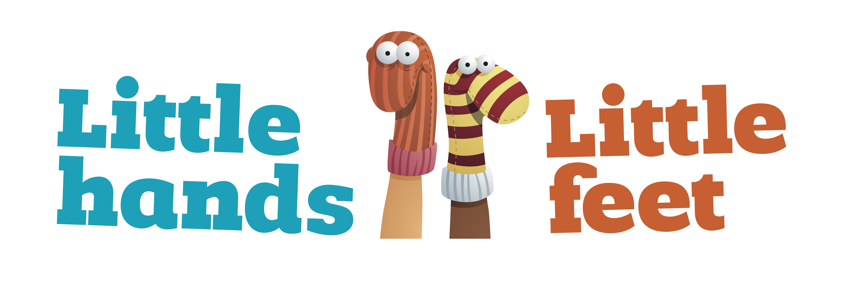

Infection Prevention and Control Policy

Reviewed July 2018 by
The Management Team

Infection Prevention and Control Policy

At all times the well being of each child when in our care comes first and foremost. The aim of this policy is to ensure that infections and illnesses are prevented and controlled to the best of our ability and that children/a child who is unwell are cared for appropriately. We kindly ask parents to cooperate with us during periods of illness.

Illness/Sickness occurring at nursery

If a child has three episodes of diarrhoea and/or two episodes of vomiting while at Little hands Little feet in order to prevent cross-infection to other children and staff, parents will be contacted and the child must be collected from Little hands Little feet Ltd immediately.

If a child develops or shows signs of an infectious/contagious disease while at the nursery for example chicken pox, measles, conjunctivitis etc. parents will be contacted to collect their child immediately. The child must be kept off for the recommended incubation period and parents within the nursery will be informed via letters/notes displayed on room doors and parent noticeboards. We kindly ask parents to notify management should their child develop an infectious/contagious disease at home. If a parent is unsure of the recommended incubation period, they should speak to their GP.

An unwell child can compromise the staff/child ratio within a room, given the situation where a child needs one to one care from staff due to an illness arising parents will be contacted to collect their child as soon as possible.

Temperature

If a child displays a temperature while in our care the below procedures will be followed by all staff at Little hands Little feet:

- We would clarify a temperature as being 37.5 C and over, when a temperature is first discovered, a record must be kept of the temperature and the time the reading was taken.
- Staff will attempt to reduce temperature naturally by removing child’s clothing and give them a drink of water. Temperature will be monitored for a further 30mins.
- If the above procedure does not reduce the temperature and a child’s temperature reaches 37.9 degrees’ paracetamol will then be administered if parental consent has been given. At this point parents will be contacted and informed of their child’s temperature as well as the steps that have been taken. The child will then be monitored for a further 1 hour. If parental consent has not been given for a child to receive paracetamol parents will be contacted to collect their child immediately.
- If after the hour the child’s temperature has not reduced and/or it remains over 37.9 parents will be contacted and asked to collect their child as soon as possible. The child will not be permitted to attend Little hands Little Feet until they are free from temperature for 24 hours without the use of medicine.
- If a child’s temperature does reduce they will be permitted to stay at Little hands Little feet for the reminder of the day, however they will be closely monitored and should they display a temperature again, whether at home or nursery, parents will be contacted to collect their child as soon as possible and will not be permitted to return to the nursery until they are free from temperature for 24 hours without the use of medicine.
- If a child instantly displays a temperature of 39 degrees or above, paracetamol will be administered and parents contacted to collect their child immediately.

We at Little hands Little feet understand that normal childhood development such as teething can occur leading to a rise of temperature, this will be taken in to consideration. However, the wellbeing of each child is paramount and as a high temperature could lead to possible further complications the above procedures will still apply when teething is suspected. If your child displays a temperature at home before coming to nursery that day, we ask that you keep them at home. A child will not be accepted if they are brought in with a temperature.

Slap Cheek (also known as Parvovirus B19 or Fifth Disease)

If while in our care a child displays the following symptoms listed below and/or display a red rash on cheeks, parents will be contacted and asked to collect their child and seek medical advice on whether their child has the named virus.

Symptoms such as:

- A high temperature
- A sore throat
- Headache
- Upset stomach
- Fatigue
- Itchy skin

Although slap cheek is a virus and no anti-biotic treatment is required, we have a responsibility and duty of care to protect pregnant staff and parents. 48-hour exclusion will apply to those who display symptoms of slap cheek.

If we have a confirmed case of slap cheek pregnant staff members and parents will be informed and recommended to seek medical advice from their GP or midwife. Management will work alongside staff to accommodate a doctor’s check-up and staff will also have the option to transfer to a different room to work until they are able to seek advice.

Exclusion Period

If a child has any of the following, the child MUST NOT ATTEND for at least 48 hours:

- If vomiting and/or diarrhoea occurs during the night/morning
- A child must be free from vomiting/diarrhoea for a period of 48 hours before returning to Nursery, and has had at least one normal motion
- If the child is taking antibiotics (from when the first dosage of medicine is administered)
- Slap cheek

To limit the risk of cross infection the 48-hour exclusion for vomiting and diarrhoea will also apply to staff, students and volunteers at Little hands Little feet.

If a child has any of the following, the child MUST NOT ATTEND for at least 24 hours:

- If a child has conjunctivitis (from when the first dosage of medicine is administered)
- If the child has a temperature (37.9C or above) or has been sent home from nursery with a temperature
- If the child has a severe cold, runny nose, persistent cough or displays that they are unfit to participate in nursery activities.

Immunisations

Children will not be permitted to attend Little hands Little feet on the same day as an immunisation due to the high risk of a reaction.

We at Little hands Little feet understand that certain health issues such as allergies, teething etc may lead to frequent episodes of diarrhoea in which the exclusion period would not apply. However, parents must provide Little hands Little feet with a medical note or letter from their GP detailing the health issue.

Administration of Medicine

Little hands Little feet will administer non-prescribed medicine to children, (such as paracetamol or ibuprofen) only when they need it and with specific written consent from parent/s.

Parent/s have an obligation to inform Unit Heads/ Nursery Assistants/ Managers of ALL medication given to their child prior to arriving at Little hands Little feet and the reason why. This is very important for your child’s safety. Prescribed medicines will not be accepted without complete written and signed instructions from the parent/s.

When registering with Little hands Little feet, parents will be asked to fill out a general consent form which includes permission for staff to administer medication. It is important to note, that if a child has a specific medical requirement, such as asthma, medicine will be administered with prior agreement and written consent from parent/s. We ask that parents to demonstrate the administration of such medicine to the staff who will be caring for the child. Any medication administered will be documented and parents will be asked to sign this document on arrival.

Each item of prescribed medication must be delivered to Little hands Little feet, in normal circumstances by the parent, in a secure and labelled container as originally dispensed or purchased. Each item of medication must be clearly labelled with the following information:

- Child’s name
- Name of medication
- Dosage
- Frequency of administration
- Date of dispensing
- Storage requirements (if important) and
- Expiry date.

Items of medication in unlabelled containers will not be accepted.

